**Maximin**

Homework #2

1) Game 1

|  |  |  |
| --- | --- | --- |
|  | c | d |
| a | 2,2 | 0,0 |
| b | 0,0 | 1,1 |

As this is a pure coordination game (the agents always receive the same payoff  
), there is no need to find Maximin value and strategy for each player because they are the same for both of them. Let’s find the Maximin value and strategy and draw payoff functions for the Orange player.

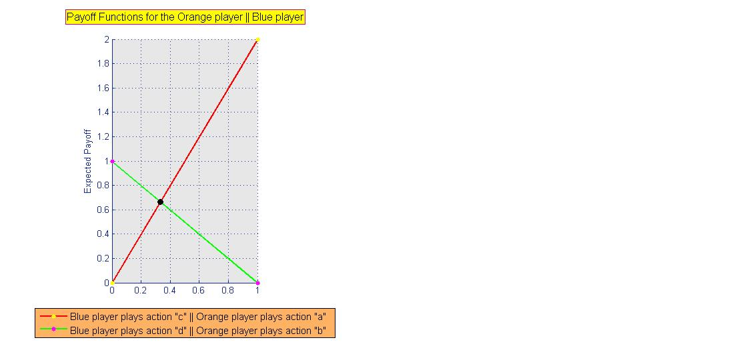

fo (p|”c”) = fb (p|”a”) = 2p + 0(1 - p)

fo (p|”d”) = fb (p|”b”) = 0p + 1(1 - p)

The figure shows that the Orange player can maximize its minimum expected payoff at the point where lines intersect.

fo (p|”c”) = fo (p|”d”)

2p + 0(1 - p) = 0p + 1(1 - p)

2p = 1 – p

p =

Thus, if the Orange player plays action “a” with a probability p = and action “b” with a probability p = , it guarantees him/her an expected payoff of (which is the Maximin value of the game for the Orange player).

πom = πbm =

2) Game 2

|  |  |  |
| --- | --- | --- |
|  | a | b |
| a | 4,4 | 0,3 |
| b | 3,0 | 2,2 |

This is a conflicting interest game. As in the previous case, it is enough to calculate Maximin value and strategy for one agent and for the second one it will be exactly the same. Let’s do that for the Orange player.

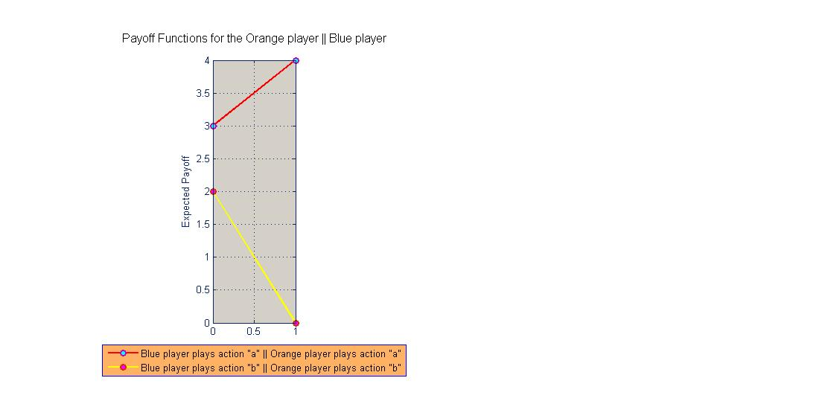

If the Orange player plays action “a”, in the worst case he/she gets a payoff of 0. Likewise, if the Orange player plays action “b”, in the worst case he/she gets a payoff of 2.

fo (p|”a”) = fb (p|”a”) = 4p + 3(1 – p)

fo (p|”b”) = fb (p|”b”) = 0p + 2(1 – p)

The figure explicitly shows (the lines don’t intersect) that there is no mixed strategy for the Orange player which is more secure than playing action “b”, with probability 1 (which is called pure strategy). The Maximin value for the Orange player is 2.

πom = πbm = 2